MINUTES
Monthly Meeting of May 18, 2020

Chairperson Dennis Graf called the monthly meeting of the Meeme Town Board to order at 6:30 p.m. on May 18, 2020 at the Meeme Town Hall. Notice of this meeting was posted at the four posting locations. Other officers present were Henry Langenhahn, Robert Christian, Grace Salm, Susan Kracht and Ian Quinn.
Minutes: Clerk Grace Salm read minutes of the April 20, 2020. A motion to approve the minutes was made by Henry Langenhahn and seconded by Robert Christian. Motion Carried.
Road Bids: A motion was made by Henry Langenhahn and seconded by Robert Christian to move the road bid process up on the agenda. Motion carried. After discussion a motion was made by Henry Langenhan and seconded by Robert Christian to approve and accept the asphaltic chip sealing bid by Scott Construction for Spring Lake Road at cost of $71,197.00, East Spring Lake Road at a cost of $8,445.00, Lorfeld Road at a cost of $10,995.00, West Washington Road at a cost of $23,435.00, Spring Valley Road at a cost of $6,468.00, and East Spring Valley Road at a cost of $3,804.00. For a total cost of $124,354.00. Motion carried. Contact signed by Dennis Graf, Chairperson. No other bids were presented.
Treasurer’s Report: Treasurer Susan Kracht reported on the following:
4/30/2020:
General Property Taxes: $12,510.59
State Local Trans. Aid: $33,927.48
County Bridge Aid: $ 1,863.53
Building Permits & Fees: $ 120.00
Recycling Income: $ 1,117.00
Sale of Recyclable Material: $ 113,00
Other Revenues: $ 1,564.22
Dog License Collection: $ 220.00
Rent: $ 885.50
Grace Salm reported that we will receive a Personal Aid Distribution – May 2020 for the amount of $483.42. A motion to approve the treasurer reports was made by Henry Langenhahn and seconded by Robert Christian. Motion Carried.

Pg. 1 of 2
Clerk’s Report: Grace Salm reported on the following: 1) The 2019 Recycling
Program Accomplishments and Actual Cost Annual Report was completed and
submitted on April 24, 2020. 2) After discussion regarding the purchase of a Dymo 450
Label Printer that is compatible with the WEC program was tabled until a price is
obtained. 3) Mailings will need to be sent to all the “indefinitely confined” voters that
voted in the Spring Election and that are requiring absentee ballot to make sure they
understand the indefinitely confined verbiage.
Constable: Ian Quinn reported on the following: 1) Complaint of sand on Pigeon
River Road.
Building Permits: Henry Langenhan issued 3 new permits.
Grota Appraisals: No report.
` Plan Commission: No report.
Roads & Equipment: Dennis Graf reported on the following: 1) There has been no
follow-up from Mr. Burrows to pay for half the cost to repair the road in front of his
business on Pioneer Road. 2) Peter Moehring has delivered salt to Lake Land College at
a reimbursement cost of $2,315.00.
Bridges: Dennis Graf discussed the following: 1) An Agreement regard
Horseshoe Lake Road is postponed until Dennis Graf follows up with Attorney Kate
Reynolds regarding the bill. 2) The MLS agreement has been signed and submitted via
email.
Recycling & Transfer Station: Peter Moehring stated he delivered another load
of scrap to B & B Metals.
Annual Meeting: The Annual Meeting is rescheduled for May 19, 2020.
2020 Open Book and Board of Review Dates: Open Book is Thursday, May 28,
2020, from 2-4 pm. Les Ahrens is available by phone and/or email due to the
Covid-19 Crisis. The Board of Review is Monday, June 22, 2020, from 5-7 pm.
Suttner Accounting: Grace Salm presented ACS Update Families First
Coronavirus Response Act 1 information.
Valders Ambulance Service: Dennis Graf stated there will be an increase for
ambulance service from $21.00 to $23.00 per capita in 2021.
County Board Member Report: Grace Salm presented the John Neils – Wisconsin
Supreme Court Blocks Safer at Home Effective Immediately report.
Public Input: No public input.
Correspondences: None to report.
Accounts Payable: A motion was made by Robert Christian and seconded
by Henry Langenhahn to approve ‘April 2020 Accounts Payable’. Motion carried.
The next meeting date will be Monday, June 15, 2020. A motion to
adjourn was made by Henry Langenhahn and seconded by Robert Christian. Motion
carried. Meeting adjourned at 7:08 p.m.
Respectfully submitted,
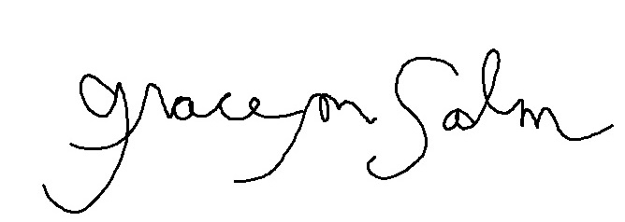
Grace M. Salm, Clerk Pg. 2 of 2

